**Speech Recognizer App:**

1. **Screen Shot :**

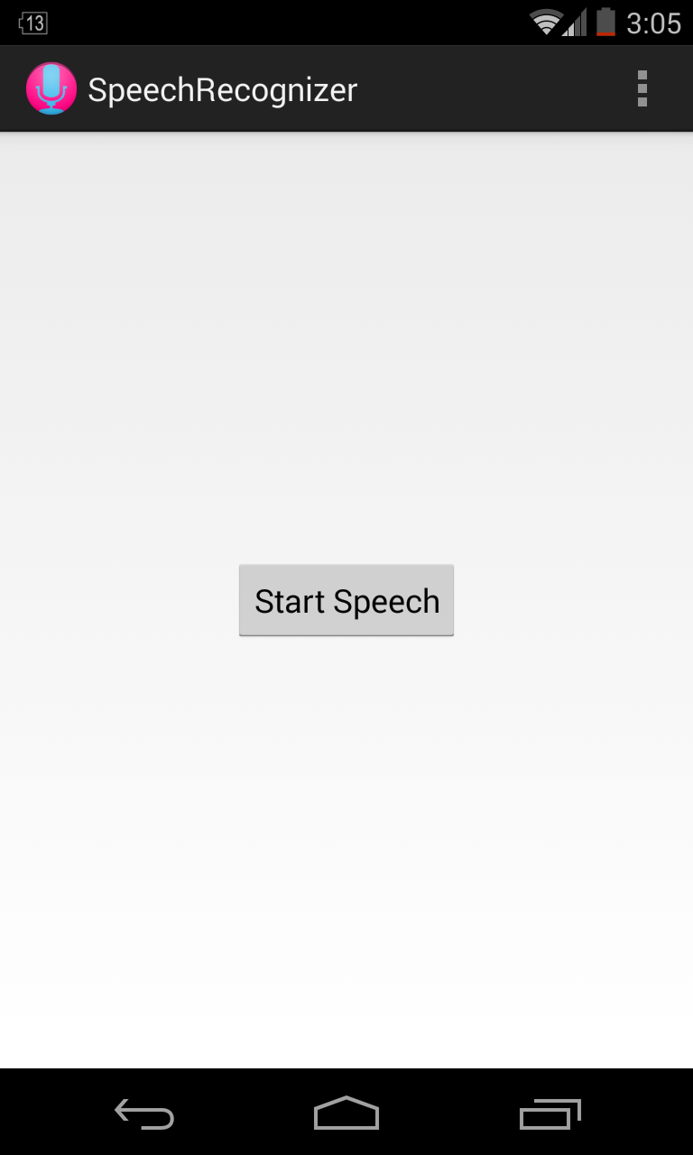

1. **Goal of the App**

To enable hands free functioning of mobile, most of the work can be done by just speech. Can be useful for everyone as it will reduce lot of work and will be very useful for blind if this is made interactive like Google now. Can be optimized in future to interact with user verbally and can introduce adaptive learning and can add security by identifying user’s voice.

Further extension may include screen lock or deleting important data in mobile phone by just sending message with exact sequence of code to that mobile by any other number, this will add extra level of security if mobile is lost.

**High Level architecture**

**Listening and Recognition of speech**

It implements RecognitionListener interface

Created a SpeechRecognizer object and sets RecognitionListener to SpeechRecognizer object.

Created the RecognizerIntent with *ACTION_RECOGNIZE_SPEECH and started recognizer object to listen on this intent.*

Override the **onResults()** method of RecognitionListener interface

Here all the speech output is matched with the app installed and if exactly matched then that particular app is opened.

Some more functions are provided other than just opening the app. Like enabling/disabling GPS,Wifi and screen lock or calling someone from phone book.

**Locking the screen**

For this Admin permission are asked, if granted can lock the screen just by voice command

Other than this this app is reading users contacts to get the number for a name.

**Android techniques**

Android speech recognition

Android Contact reading

Android Admin Permission

Starting other apps

**Testing**

1. Install the app on android enabled device.
2. Device should have mic
3. Launch the App
4. Press the Start Speech Button and say the “command”, app will do accordingly

Here command includes:

1. Any app name : this will open that app if pronounced correctly
2. Wifi on : turn on the wifi
3. Wifi off: turn off the wifi
4. GPS: open the GPS setting page where you can turn on the GPS, it requires manual intervention as required by android security feature
5. Lock: will lock the screen
6. Call ‘name’ : will start call to the name in contact if matches exactly